TEAM5OARS Data:

TESTIMONIAL (3 records)
T_ID | CONTENT | DATE | TENNANT_SS
1 | I really like TEAM?OARS Online Apartment Rental System! | March 31, 2002 | 123456789
2 | I think that this TEAM?OARS website can be improved! | April 9, 2002 | 450452267
3 | I believe that the Tenants and Visitors will like TEAM?OARS since they can rent and manage apartments online. | April 25, 2002 | 173662690

APARTMENT (9 records)
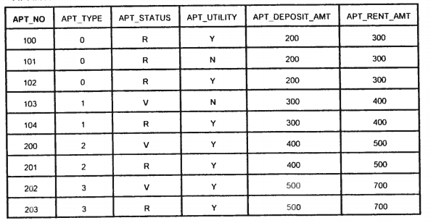

RENTAL (6 records)
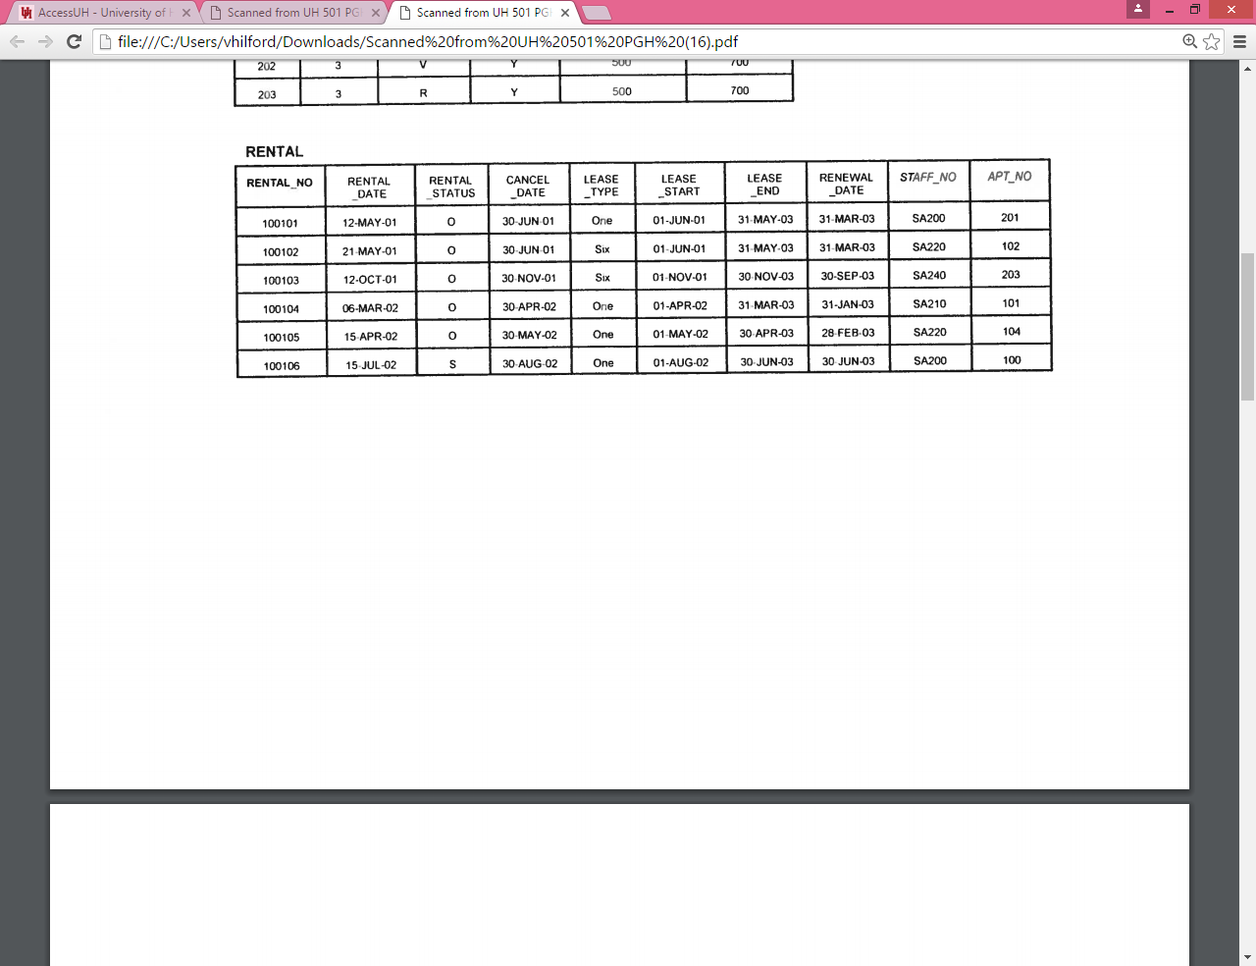

COMPLAINTS (7 records)
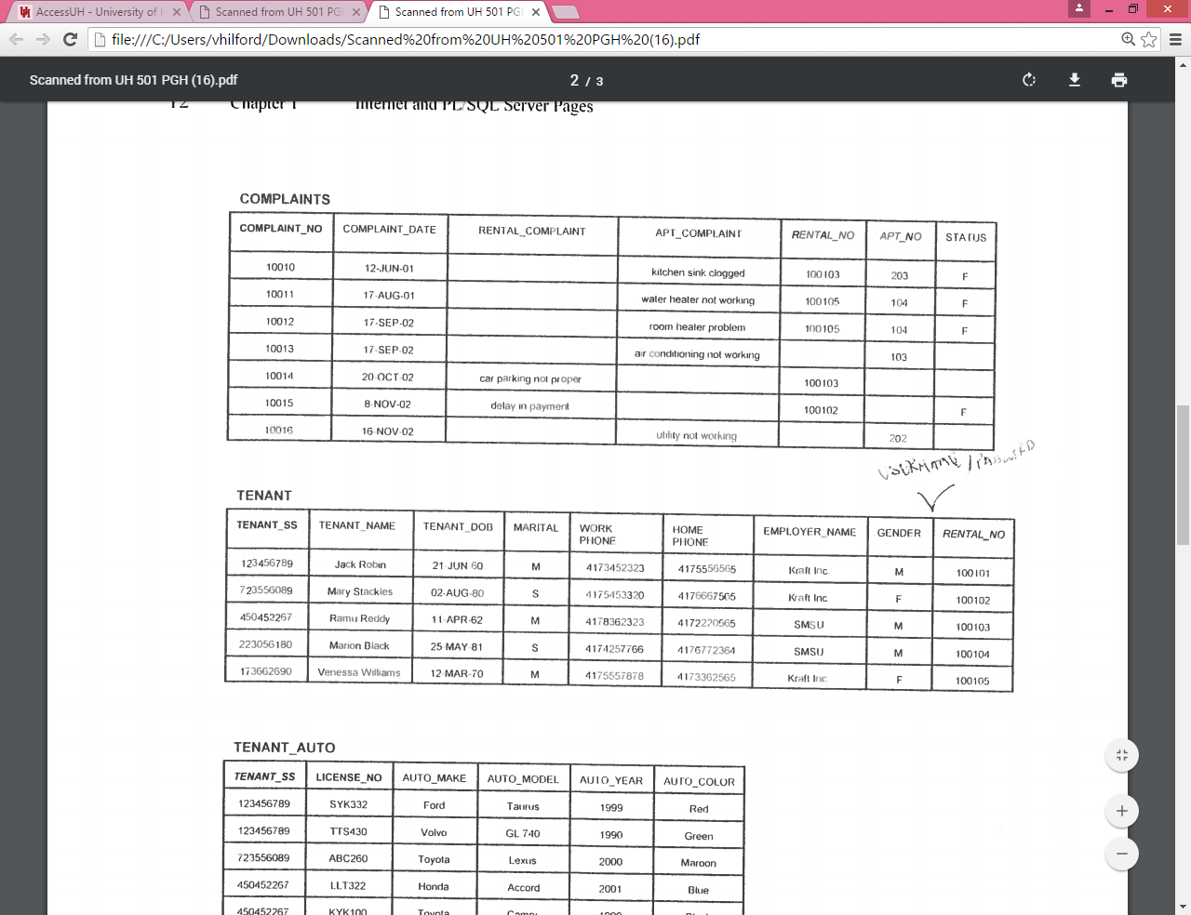

TENANT (5 records)
USERNAME
PASSWORD
TENANT1
TENANT1#
TENANT2
TENANT2#
TENANT4
TENANT4#
TENANT3
TENANT3#
TENANT5
TENANT5#

TENANT_AUTO (7 records)
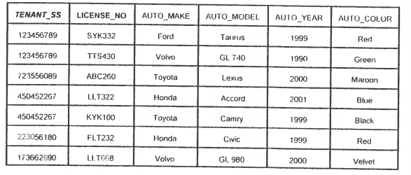

TENANT_FAMILY (5 records)
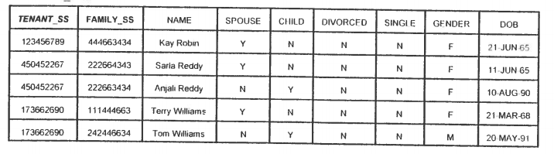

STAFF (5 records)
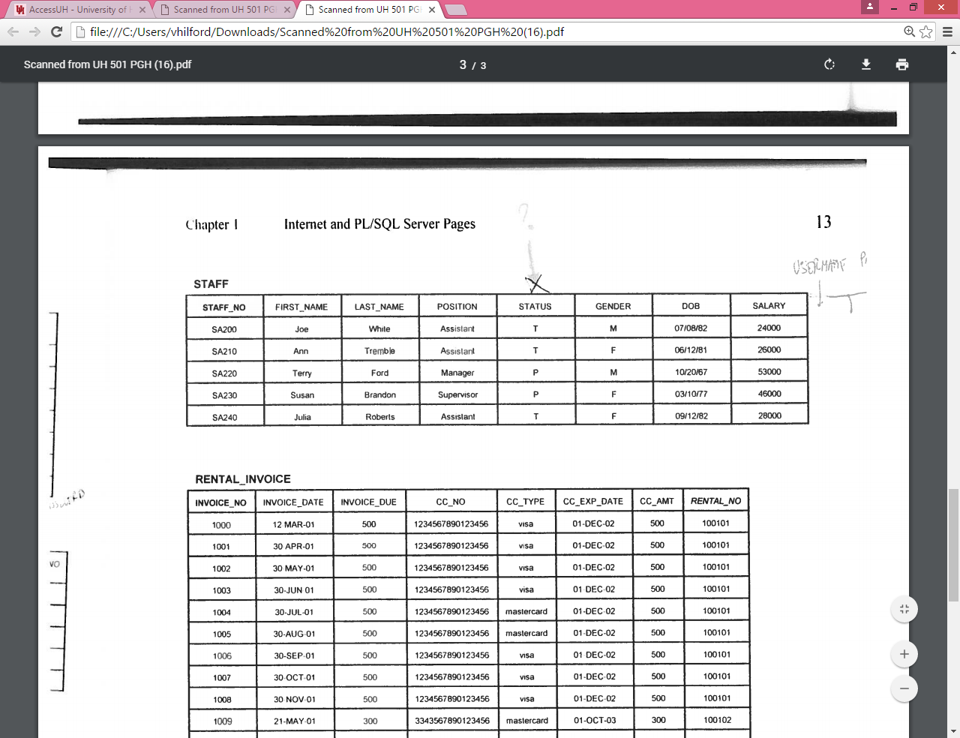

USERNAME
PASSWORD
ASSISTANT1
ASSISTANT1#
ASSISTANT2
SUPERVISOR
MANAGER
MANAGER#
ASSISTANT3

ASSISTANT2#
SUPERVISOR#
ASSISTANT3#

RENTAL_INVOICE (27 records)
